The first Parish Council meeting of 2016 took place at Ecchinswell Village Hall on 13th January.
We have certainly been experiencing some very wet weather during this winter but this does not seem to have deterred the large number of walkers who visit the Parish to enjoy our wonderful countryside. It is in all of our interests to keep our paths and bridleways free from obstructions so please let us know if you find any obstructions or damage which affect access on the footpaths.
Once again the Parish has benefited from the invaluable help we receive from the Lengthsman scheme. Maintenance work took place in December in the Digweeds area as well as the allotment site. This month vacant plots will be dug over with a rotavator to get them ready for spring occupation. If you are interested in taking up an allotment without quite so much digging being required - We have at least three plots available - please contact our Clerk on clerk@ecchinswell-pc.gov.uk
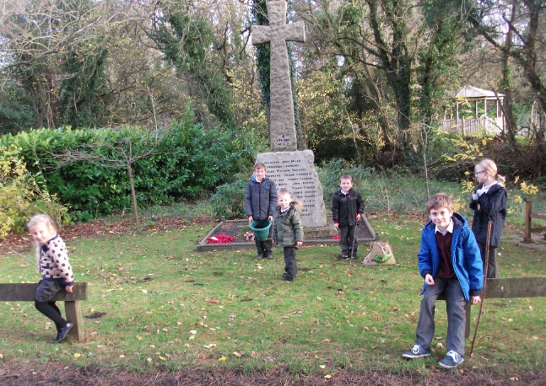
The autumn bulb planting project, run in conjunction with the Primary School, (see adjacent picture) has been a great success. It should not be long now before the children will be able to see the results of their enthusiasm and hard work. This is something everyone can enjoy and it is hoped that something similar can be done again later this year.

One thing that has become increasingly apparent during this wet winter is the amount of flooding that is occurring on our lanes; often due to blocked drainage or inadequate ditching. An assessment by Councillors was carried out in the Christmas break and attempts are being made to identify areas of responsibility with local landowners to try to improve the situation. Please note that landowners are responsible for the maintenance of ditches and the drainage of water on their land adjacent to the roadway. If you are affected by any particular areas of standing water, please contact the Clerk or any of the Councillors.
Finally, following the very successful work carried out to the entrance drive of the Ecchinswell Village Hall late last year funded by a grant secured by the Parish Council, further improvements are currently being undertaken in the car park area. This is to replace the worn paving slabs around the building and to re-mark the parking bays. Feedback from this project has been extremely positive and it is hoped that the work will be completed shortly.
The next meeting will take place on Wednesday 10th February at the above venue. As always, members of the public are very welcome to attend.
Cllr Jackie Bayliss

