Ecchinswell, Sydmonton & Bishops Green Parish Council Newsletter
September 2022
On behalf of the residents of the parish of Ecchinswell, Sydmonton and Bishops Green, I would like to express our sadness at the death of Her Majesty the Queen. We extend our deepest sympathy to His Majesty The King and to the members of the Royal Family.

As a result of The Queen’s passing our parish council meeting for September was postponed until after the period of official mourning and held on the 28th September, too late for this edition of News From The Villages. We will report on this and the October meeting in November’s edition.

Much has been happening over the summer in the parish. The Neighbourhood Plan has reached its Regulation 14 Pre-submission Stage where the community and statutory consultees have had the opportunity to see the plan and make comments. The plan has been developed from the consultations held over the last 18 months and we trust reflects what the community has told us. We hope you have had a chance to look at the plan by now and have made your comments to us. Do let us know if the plan reflects your wishes. It is just as important for you to register agreement as it is to raise any concerns you have. The closing date for the consultation is the 7th October 2022 and the plan can be found at https://tinyurl.com/37buburk and comments should be sent to the parish clerk (clerk@ecchinswell-pc.gov.uk ) and n.plan.esbg@gmail.com

In relation to wider planning, can I urge you to read Richard Carrow’s article in this edition detailing the change in planning policy direction at Basingstoke & Deane Borough Council under the new Leader, Cllr Simon Bound. This potential reduction in housing numbers may be beneficial for the borough in the long term but pursuing this reduction will delay the production of the B&DBC Local Plan Update. This means that the successful adoption of our Neighbourhood Plan is even more important to protect us from current and future predatory development proposals.

Two stiles to gates projects have been completed in the parish over the summer; one in Ecchinswell on the footpath from the Kingsclere Road to the War Memorial and one just south of Bishops Green from The Old Sun House to Hyde Lane. Both can be used to form part of lovely circular walks in our parish. The gates were installed by parish residents and other volunteers with the help of Hampshire County Council. Hampshire County Council provided grant money for the gates and our Hampshire Community Engagement Ranger helped us to install them to the correct standards! We hope you enjoy the improved access.

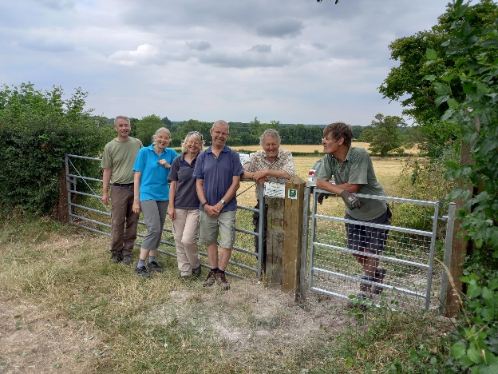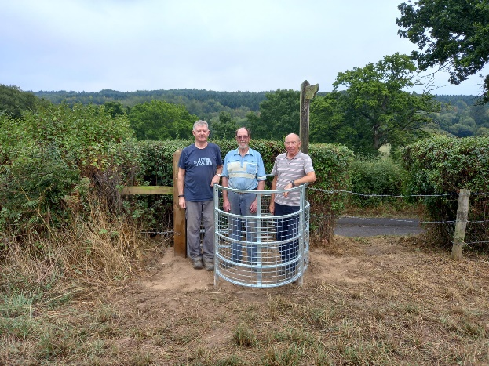

Sunday the 16th October sees our annual Pond Clearance event. We start around 10am and work until the early afternoon with a break for refreshments – likely to be sausage or bacon rolls! This is an opportunity for residents to come along and join in for as much time as they can spare clearing the overgrown areas of weed and rushes. It is a very sociable event so do come and join us – no experience necessary, just a willingness to get a bit muddy!

Our next meeting will be on Wednesday 12th October 2022 at Ecchinswell Village Hall starting at 7.30pm. Everyone is welcome.

Cllr Marian Dain

