Chairman’s Report - 8 May 2013

The Chairman of the Parish Council, Councillor Tim Hall welcomed all those present
He then introduced the parish councillors – who all volunteer their free time to take part in the council’s activities.

- John Broxis - Vice Chairman
- Malcolm Jones
- Ian Cameron
- Margaret Curtis
- Daniela Court (away)
- Alan Meredith (is away on business)

And the parish clerk - Doreen Gascoine – who, as the only paid representative, ends up doing most of the work and keeps us in order. Our thanks to her for her expertise and diligence.

And now our guest speakers;
- John Izett - Borough Councillor
- PC Matt Deery and PCSO Abbey Carpenter
- Steve Pellatt, Hampshire Highways

…all of whom you’ll be hearing from shortly.

So – as I’m sure you’re aware, a Parish Council is the first tier of local government and the closest to the community that they represent.

The councillors are elected for a four year term, although an actual election is only necessary if there are more people wanting to be parish councillors than there are vacancies.

The Parish Council has a number of required formal duties, procedural and financial which include:
- The right to raise money by precept. The precept forms a small portion of your overall council tax account and, this year, represents about 1.8% of your annual council tax bill – which for a band D property is £2.14 per month. It’s our job to ensure that your contributions are spent wisely for the benefit of our parish.

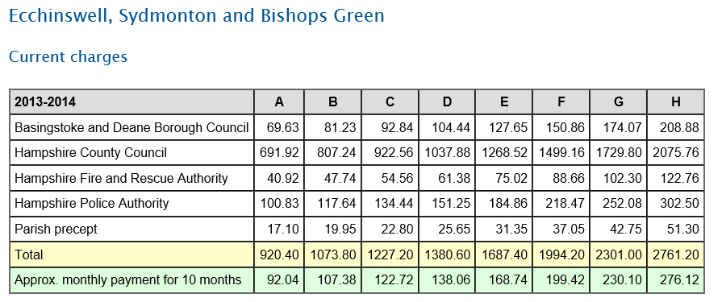

- Provide annual audited accounts, publish minutes from monthly meetings
- Provide allotments and an appropriate watering facility
- Maintain amenity areas, for example Digweeds and the village pond
- Look over/after rights of way
- Maintain bus shelters
- We are also consulted on matters such as planning applications.
- The clearing of litter
- And financially assisting local charity or volunteer groups where possible

The Parish Council meets on the second Wednesday of every month excepting August here in the Ecchinswell Village Hall. Please come along if you’d like to raise any questions about what we do or make suggestions on how we can improve the parish for all of us. The agendas for the meetings are posted on five Parish notice boards: BG Community Centre, EVH, Eagle Road, Ecchinswell Pond and the Royal Oak. And on our website.

We employ two part-time litter wardens who do a splendid job clearing litter that others leave behind. Please say hello to them when passing as I’m sure they would appreciate the acknowledgement. If you see someone dropping litter…please make a note and pass on to us.

Traffic – the PC made a significant effort to minimise the effect of additional traffic through the village before and during the A339 road works. I can’t say we were 100% successful, but I do think our representations to Highways, Borough and County Councillors and the Police helped to mitigate some of the traffic issues.

Speeding: We’ve all suffered from this over the last year or so – and, just because the A339 road works are over, doesn’t mean that speeding has gone away. We will continue to monitor this and I’m sure PC Matt Deery may have a few words to say on this later.

On the subject of the roads – we’re due to have another closure that will affect us all. The main road through Bishops Green will be closed for up to three months – starting possibly next month – to repair the drains under the roadway. There will be diversions set up and extra care will need to be taken by everyone on the smaller side roads that may be used for rat-running – particularly Hyde Lane and Featherbed Lane.

Broadband: We’ve been aiming to get further up the priority list for improvements to our broadband service. Most of which is pretty poor in this area – but government funding is available, contracts have been signed and, in those rural areas where the most demand is, BT will be focusing on rolling out a better service. A year ago, only 75 of the 420 households in our parish had registered their interest – as of Monday this week that number is now 213 registrations. So we’re over 50%.....just. But we need more. Please will you tell your friends and neighbours in the parish to register their interest on the Hampshire broadband website. Leaflets are available here.

I now hand you over to Doreen Gascoine who will go through details of our finances.

